
RTO NSW Department of Education 90333

Student Package
CPC20220 Certificate II in Construction Pathways & Statement of Attainment towards CPC20120 Certificate II in Construction
Task 5 - Brick and Block Laying

Units of competency assessed:
CPCCBL2001 Handle and prepare bricklaying and blocklaying materials & CPCCBL2002 Use bricklaying and blocklaying tools and equipment

List any pre-requisite or co-requisite units of competency:
CPCCWHS2001 Apply WHS requirements, policies, and procedures in the construction industry
Training Package Title (release #) | CPC Construction, Plumbing and Services Training Package Release 9.0
Qualification Code and Title (release #) | CPC20220 Certificate II in Construction Pathways & Statement of Attainment towards CPC20120 Certificate II in Construction
School name | Insert school name and if applicable the school logo
Location (if different to school) | Insert location
Assessor name | Insert assessor name
Assessment date of issue | Insert date
Assessment due date | Insert date
Context for assessment | The student is to be assessed on their ability to demonstrate that they can:  - Plan brick and block laying work  - Handle, sort and stack materials  - Prepare brick and block laying work  - Mix brick and block laying mortar  - Use brick and block laying plant, equipment and tools  - Clean up
The sections are broken down into the following:
Section 1: Written Questioning
Part A
Part B
Part C
Section 2: Product Based Methods
Part A – Work Plan Bricklaying Project
Part B – Work Plan Blocklaying Project Preparation
Section 3: Direct Observation
Part A – Observation Checklist – Scenario Simulation
Part B – Observation Checklist – Planning
Part C – Observation Checklist – Project Preparation
Part D – Observation Checklist – Bricklaying
Part E – Observation Checklist – Cleanup

Each section will be reported as Satisfactory (S) or Not Yet Satisfactory (NYS). When all components of a task are completed satisfactorily the student outcome for the unit will be Competent.
These can be performed either in an industry workplace or a simulated industry environment.
The school will provide safe and well-maintained facilities, equipment, tools and materials as required for each individual unit of competency in order to allow the assessment to be undertaken
Reasonable adjustments allowed | All students must be provided the opportunity to access and participate in the learning and assessment process. Reasonable adjustment must be discussed with individual students prior to assessment. Reasonable adjustments are implemented to provide equitable access for students while maintaining the integrity of the qualification and industry outcome. All reasonable adjustments must be documented on the student assessment copy

Assessment Package Outline
Students must complete all components of the assessment to a satisfactory level to be deemed as competent for a unit of competency.
Assessment Method | Units of Competency | Duration (indicated hours)
Section 1:  Written questioning | CPCCBL2002 – Use bricklaying and blocklaying tools and equipment  CPCCBL2001 – Handle and prepare bricklaying and blocklaying materials | 1 hour
Section 2:  Product based methods | CPCCBL2002 – Use bricklaying and blocklaying tools and equipment  CPCCBL2001 – Handle and prepare bricklaying and blocklaying materials | 1 hour
Section 3:  Direct observation | CPCCBL2002 – Use bricklaying and blocklaying tools and equipment  CPCCBL2001 – Handle and prepare bricklaying and blocklaying materials | 6 hours

Section 1: Written Questioning

Time | Each student has 1 hour to complete this section.
Assessment Instructions | Each student must complete Section 1 – Written Questioning.  During Assessment:  - If the student does not answer a question in full, the teacher may ask the student to provide more information to be deemed satisfactory. If this is required, the teacher must document the question they ask the student and document the response against the question requiring further information.  - Ensure all responses are a student’s own work.  After the Assessment:  - After completion, the teacher will hold a debrief (feedback) session with the student. The student will share any insights or lessons they have gained and discuss any takeaways that could be applied to real-life situations.
Student must demonstrate | Knowledge as required by the unit of competence through all written activities.  - terminology relating to bricklaying and blocklaying tools and equipment  - relevant building and construction standards and codes  - basic construction terminology  - features and purpose of plans and specifications  - manufacturer’s specifications and instructions for tools and equipment:  - safety requirements during operation  - location and purpose of parts  - uses and limitations  - cleanliness and maintenance  - troubleshooting problems  - functional and operational features of plant, equipment and hand and power tools:  - wheel barrow  - spirit, pocket and water level  - automatic and laser level  - trowels and jointing tools  - corner blocks and string lines  - tingle plate  - profiles and straight edges  - bolster chisels  - mash hammer/lump hammer  - builder square and sliding bevels  - power drills  - battery operated tools  - pallet trolleys  - materials hoist  - brick buggies  - elevators  - scaffolds  - small petrol or diesel engines, compressors and cement mixers  - forklifts  - brick cutting saw  - characteristics, applications and limitations of specified materials for bricklaying and blocklaying:  - clay bricks  - solid and hollow bricks  - pavers  - refractory bricks and mortars  - natural and manufactured stone  - aggregates, cement, lime, mortar additives  - processes and techniques for:  - laying bricks and blocks  - mixing mortar  - manual handling  - mechanical handling  - workplace safety:  - job safety and environmental analysis (JSEA)  - hazardous manual tasks  - electrical safety, hazards and the use of earth leakage boxes  - noise reduction  - dust suppression  - working at heights  - exposure to silica  - exposure to loud noise  - environmental requirements relating to workplace processes and waste disposal
Student to submit | Each student must submit the following evidence:  - Section 1 – Written Questioning.
Resources | Each student will be provided with the following resources to complete the assessment task.  - Section 1 – Written Questioning.

Part A – Terminology and Materials

- Match the brick and block laying term to its explanation, using an arrowed line.

Bricklaying Term |  | Explanation of the Bricklaying Term
Bat |  | Trowelling of mortar into mortar joints after bricks have been laid to ensure there are no visible voids.
Brick veneer |  | A 1m x 1m material where mortar is placed once mixed. It is usually raised to reduce manual handling stresses.
Extruded |  | 2 : 1 : 1 : 6 (Water : Sand : Lime : Cement)
Mortar board |  | When a brick is cut across the width, thus smaller in length than the full brick.
Concrete block |  | A method of construction in which a single leaf of non-load bearing wall of brickwork is tied to a timber or metal framed load bearing structure to form the external enclosure.
M3 mortar ratio |  | 'Bricks with holes”. The holes decrease the weight of the product and require less materials to make.
Dry Pressed |  | Bricks are laid with only their stretchers showing, overlapping midway with the courses of bricks below and above.
Mortar |  | A mix of sand, cement, lime and water that bonds bricks together.
Pointing |  | Also known as Besser Blocks. Larger in size than common bricks, with large internal holes. Can be filled with concrete and steel reinforcement for strength.
Stretcher bond |  | Bricks made by pressing clay into individual moulds at a very high pressure, producing solid bricks.

- Match the numbers from the picture to the brick terms listed.

Brick terms | Number on picture | 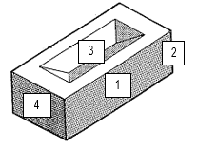
Frog
Header face
Stretcher face
Arris (edge)

Instructions: To demonstrate your knowledge of brick and block laying materials, complete the Brick and Block Materials table below by inserting the number of the correct response from the Table of Answers.
The correct responses for Q.3 (Characteristics) can be found in Q.3 of the Table of Answers below, the correct responses for Q.4 (Applications) in Q.4 of the Table of Answers and the correct responses for Q.5 (Limitations) in Q.5 of the Table of Answers.
Brick and Block Materials
Material | Q.3  Characteristics | Q.4  Applications | Q.5  Limitations
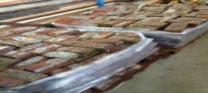
Clay bricks
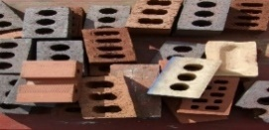
Solid and hollow bricks

Pavers
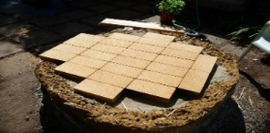
Refractory bricks and mortar

Natural and manufactured stone

Table of Answers
Q.3 |  | Q.4 |  | Q.5
1 | Various colour and material choices to suit application. Durable. Weather resistant. Low maintenance and can repair individual pieces. Aesthetically pleasing. | 6 | Driveways, terraces, pool areas and paths | 11 | Time consuming and requires highly skilled layers. Imperfections including fissures, cracks, chips and pitting
2 | Various colour and material choices to suit application. Suits a range of budgets. Durable, low maintenance and can repair individual pieces. | 7 | Load bearing walls and low rise residential | 12 | Heavier than other options. Harder for plumbing and electrical. Heavier foundations required
3 | Keeps interior warm in winter and cool in summer. Good sound insulation. Light. Various colours. | 8 | Kilns, furnaces, chimneys and ovens | 13 | Weed growth, fading colour and tree roots can make them uneven
4 | Low maintenance, durable, thermal properties, affordable, readily available | 9 | Load bearing walls and facades | 14 | Better load bearing options available. Limited ability to hold heavy hanging objects
5 | Can withstand high temperatures and weather resistance | 10 | Retaining walls, pool areas, bathrooms and kitchens | 15 | Heavier than other options. Poor sound insulation. Need replacing every 5 - 10 years.

Instructions: To demonstrate your knowledge of brick and block laying materials, complete the Brick and Block Materials table below by inserting the number of the correct response from the Table of Answers.
The correct responses for Q.6 (Characteristics) can be found in Q.6 of the Table of Answers below and the correct responses for Q.7 (Limitations) in Q.7 of the Table of Answers.
Bricklaying Materials
Material | Q.4  Characteristics | Q.5  Limitations

Aggregates

Cement

Hydrated Lime

Mortar additives

Table of Answers
Q.6 |  | Q.7
1 | Adds flexibility, slows hardening, and reduces the effects of movement stresses | 5 | May not meet Australian Standard clay content, reducing mortar mix durability and strength
2 | Improves water resistance, workability and efflorescence control. Changes mortar setting times. | 6 | Can separate from cement after mixing, reducing the qualities of the mortar mix
3 | Adds strength, binding, and moisture resistant properties to mortar | 7 | Low tensile strength, ductility, strength to weight ratio and susceptible to cracking if foundations move
4 | Brickie sand contains a high amount of clay which becomes sticky and workable for bonding | 8 | Incorrect proportions will reduce the qualities of the mortar mix

- Identify the application of brickies sand, cement, hydrated lime and mortar additives.
- Component of mortar for load bearing brick walls, limestone blockwork and rendering
- Used to create environmentally friendly runoff areas on the worksite
- Component of materials for load bearing wall frames, paint and kitchens
- Component of materials for tiling adhesive and tiles

Part B – WHS and Documentation

- Identify the Australian Standard which sets out the design and construction requirements for masonry structures.
- OZ-9-007 Brick Buildings Code of Practice
- Construction Code of Practice
- AS3700 Masonry Structures
- ASX-64 Brick and Masonry Standards

- Identify the Code of Practice brick and block layers must adhere to.
- OZ-9-007 Brick Buildings Code of Practice
- Construction Code of Practice
- AS3700 Masonry Structures
- ASX-64 Brick and Masonry Standards

- Brick and block layers use a variety of plans to ensure they are complying with standards and building features. Match the construction plan to details and specifications it provides brick and block layers, using an arrowed line.

Construction Plan |  | Details and specifications it provides brick and block layers
Site Plan |  | Wall length and engaged pier specifications and detail
Floor Plan |  | Brick and window height
Elevation Plan |  | Distance from boundary for retaining wall
Section Plan |  | Weephole, flashing and cavity tie details
Detail Plan |  | Brick type, location, and tie structure

- Identify important workplace considerations and practices when loading bricks onto brick stacks.
- Avoid placing directly on the ground
- Place close to work face to reduce manual handling
- Level ground before placing bricks
- Stacked on edge face up 600 mm from wall face
- Keep uncovered in case it rains so that they can be washed clean
- Move the bricks one at a time
- Never use mechanical handling devices as they always damage the bricks

- Identify correct brick and block laying related manual handling techniques.
- Make sure your feet and body are stable before lifting materials
- Never use mechanical handling devices as they always damage the bricks
- Use a brick carrier and wheelbarrow when possible
- Move your feet and don’t twist your torso when moving bricks from the stack to lay on a wall
- Keep the material load close to your body
- Keep the material load away from your body
- Bend your back and keep your knees straight when picking up bricks near to the ground

- A JSA may be used when planning a standard brick or block laying task. Identify what the JSA initials stand for.
- Job Safety Analysis
- Job Sequencing Affect
- Junction Sequencing Analysis
- Junction Safety Analysis

- Construction companies will sometimes add environmental analysis to a Job Safety Analysis (JSA) document. Identify the initials used for the document with both safety and environmental analysis within it.
- JSAE
- JESA
- EJSA
- JSEA

- A SWMS may be used when planning a high-risk brick or block laying task at heights. Identify what the SMMS initials stand for.
- Safe Work Material System
- Safe Work Method Statement
- Safe Water Management System
- Safe Workplace Management Strategy

- Workplace injuries can occur suddenly or over time. Identify which of the following activities would be considered to be a hazardous manual task.
- A task involving repetitive or sustained force
- A task involving repetitive movement
- A task involving low force
- A task involving exposure to vibration

- Electric cement mixers can present electrical hazards if not operated correctly. Identify the correct workplace procedures to remain safe while mixing brick and block laying mortar.
- Use the cement mixer in damp or wet places. Use them in rain because they are a durable machine and helps with cleaning process
- Confirm the switch is in the OFF position before inserting the power plug into a Residual Current Device (RCD) or mains power outlet with an earth leakage device
- Handle the cement mixer electrical plug with wet hands
- Lock switches in 'ON' position with tape or wire if it means the job can be done faster

- One of the most common effects of noise pollution is noise induced hearing loss (NIHL), which is irreversible. Identify which of the following statements, regarding workplace noise, is correct.
- While noise pollution is a real problem in construction sites, there is nothing you can do about it
- Prolonged exposure to loud noise can also cause high blood pressure, heart disease, sleep disturbances, and stress
- Loud brick cutting saws are less noisy when the blade starts to show signs of wear
- When using loud machinery, it is permissible to not wear earmuffs if the work activity takes less than 30 minutes

- Construction-site operators and owner-builders are required by law to minimise dust emissions from their sites. Identify the correct workplace procedures to reduce worksite dust emissions.
- Cover material stockpiles
- Use a blower vac to keep the dust off your construction site
- Use water to suppress dust when cutting bricks and blocks
- Install dust screens around the site’s edges

- It is important to know that noise doesn’t have to be painful to be doing damage to the human ear. If you have to raise your voice to be heard, the noise level is likely to be 85 dB(A) or more and capable of being harmful to your hearing. Identify which of the following statements, regarding workplace noise reduction, is correct.
- Monitor work schedules to check that noisy work is carried out as specified, away from other workers and during approved hours
- Monitor whether training has been carried out and if personal hearing protection is adequate, and being worn and maintained correctly
- Based on the Hierarchy of Hazard Controls, hearing protection PPE use should be the first hazard and risk control to implement
- Monitor identified noisy areas. Make sure these areas are well marked so workers and contractors can avoid entering them unnecessarily.

- If the workplace involves working at heights, the associated risks should be reviewed and planned for. Appropriate procedures should be implemented, and safety equipment obtained. Identify the correct workplace procedures to reduce injuries when working at heights.
- Work on the ground where possible
- Secure guardrails, fences and toe boards to any raised platform, including scaffolding
- Working on a ladder is acceptable if the work activity takes less than 30 minutes
- Use fall restraint systems

- Silica dust is harmful when inhaled into your lungs and can lead to the development of lung cancer. Identify which of the following products may contain Silica dust.
- Bricks, timber and tiles
- Bricks, tiles and concrete
- Tiles, concrete and plywood
- Mortar, hardwood, bricks

- Identify environmental considerations when cleaning up on a construction site.
- Use wet methods to limit dust when sweeping
- Hose all waste into the gutter or storm water drains
- Try to recycle us much as possible and place offcut materials in the appropriate bin
- Disposal of hazardous materials following SDS advice. (eg used paint thinners in empty container and drop at waste facility)
- Use a blower to blow all dust away from the site

- Identify where you can find environmental requirements for a Construction project.
  - Environmental Management Plan
  - Job Safety and Environmental Analysis (JSEA)
  - Pedestrian Traffic Plan (PTP)
  - Environmental notes within construction plans
  - Microwave Radiation Plan (MRP)

Part C – Tools, Equipment and Processes

- Identify the correct procedure order for mixing mortar in a cement mixer.
Procedure | Order
Set up, level and stabilise the cement mixer
When no more mortar is required, wash inside and outside the bowl with clean water
Locate a flat work area, close to mortar materials
Connect cement mixer to an RCD and fit PPE for hearing and respiratory protection
Conduct a preoperational check on the cement mixer including reading the manufacturer’s instructions, JSA, SOP, checking guards, leads for damage and tags
Wet down the mixer bowl with water. Gauge materials, load mixer (starting with water) and leave to combine. The ratio should be 2:1:1:6 (Water : Cement : Lime : Sand).
Once combined, position a wheelbarrow in place below the bowl, tilt the bowl using the handle so that the mortar mix enters the wheelbarrow.

- Identify the correct procedure order for laying bricks and blocks.
Procedure | Order
Clean area, set up and mark out bottom course as per plan. Check foundation or footing levels, which will assist with the possible varying thickness of the first mortar bed.
Remove the dry blocks from the foundation or footing and spread a 15mm layer of mortar (mortar bed), along the foundation or footing, to the length of about 5 bricks. Furrow the mortar bed with the trowel.
As each course is complete clean off excess mortar with your trowel so that it is flush with your bricks. Do not apply a finish to the joints straight away, as the mortar will be too wet.
Set up a vertical profile at each end of the wall and then run a string line between the two profiles to give you the exact line of the wall face. Use a laser level to set the string line height of the 1st course.
Place the corner/end brick in place squarely up against the string line. Tap this brick down with the trowel handle bedding it into the mortar.
All subsequent blocks will require buttering, which means that you need to spread 10mm of mortar onto end of the brick being pushed into an existing laid brick.
After each course is laid and cleaned, lift the string line up the profiles for the next level to begin.
Determine the number of bricks per course by laying out a course of bricks, without mortar, along the foundation or footing. The bricks should be laid around 10mm apart to allow space for your mortar.
Continue to place bricks gently in line with the previous bricks, up against the string line, using your spirit level very frequently to ensure that the wall stays level and true. When only one brick remains to be laid, cut the brick to size using the brick bolster or brick saw if required. Butter both ends and gently place.

- Identify information you would find within the manufacturer’s operator manuals of brick and block laying tools and equipment.
- Specifications and instructions for use
- Brick and block dimensions
- Safety requirements during operation
- Location and purpose of parts
- Mortar mixing ratios
- Safety Data Sheet (SDS)
- Uses and limitations
- Cleaning and maintenance instructions
- Brick and block project plans
- Troubleshooting problems

- Brick and block manufacturer operator manuals contain important information that you should read and interpret before using tools and equipment. Match the manufacturer operator manual information to its description, using an arrowed line.

Operator Manual Information |  | Description
Specifications |  | A step-by-step procedure guide on the safe operation and operating functions of the tool or equipment
Instructions for use |  | A list of features and steps that must be taken prior, during and after use to reduce the risk of injury
Safety requirements |  | Product dimensions and performance capabilities
Location and purpose of parts |  | A list of performance capabilities and actions the tool or equipment is designed to undertake, allowing a user to identify what activities it should not be used for
Limitations |  | Usually in the form of a picture and key, it identifies and describes how the tool or equipment is built, and assist the user understand the instructions for use and safety requirements
Cleaning and maintenance instructions |  | A list reasons the tool or equipment may not be working or functionating efficiently, and possible solutions to rectify these
Troubleshooting |  | A step-by-step procedure guide on how to care for your tool post use, to ensure tool or equipment efficiency and a reduction in break downs

- Match the mechanical manual handling aids, plant and equipment to its operational features, using an arrowed line.

Mechanical manual handling aids, plant and equipment |  | Operational Features
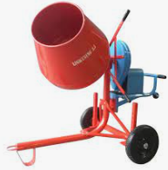 Cement mixer |  | A hand tool designed to carry 6 to 12 bricks in a single movement, reducing manual carrying activities required by workers
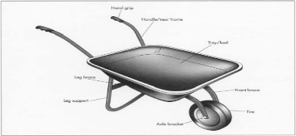Wheelbarrow |  | Designed to mechanically mix brick and block mortar materials, reducing manual mixing activities required by workers
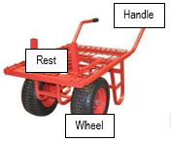Brick buggies |  | A wheeled device, designed to hold and transport brick and block tools, equipment, bricks, blocks and mortar, reducing manual carrying activities required by workers
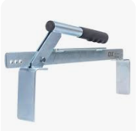Brick carrier |  | A 2-wheeled device, designed to hold and transport brick, blocks and materials that will not fit in a wheelbarrow, reducing manual carrying activities required by workers

- Match the mechanical manual handling aids, plant and equipment to its operational features, using an arrowed line.

Mechanical manual handling aids, plant and equipment |  | Operational Features
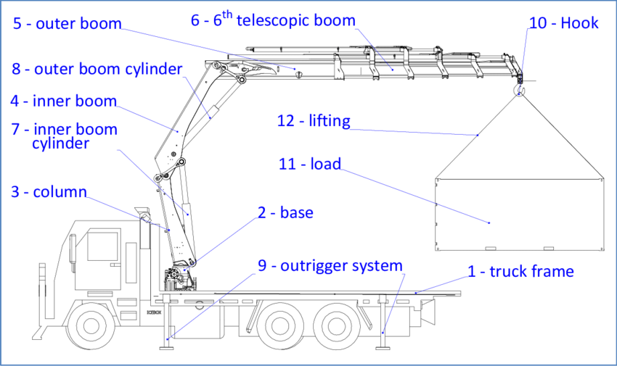Material hoist |  | A wheeled device, designed to hold and transport brick and block materials on a pallet, reducing manual carrying activities required by workers
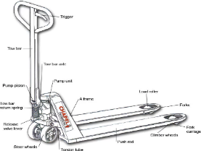Pallet trolley |  | Usually attached to the delivery truck, this device moves whole pallets of brick and block materials onto the worksite, reducing manual carrying activities required by workers
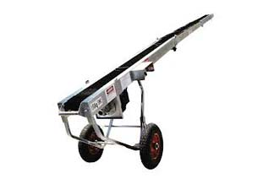Elevator/conveyor |  | A wheeled device, designed to hold and transport brick and block materials on a pallet, reducing manual carrying activities required by workers. Includes fork tilt, side movement and several safety features.
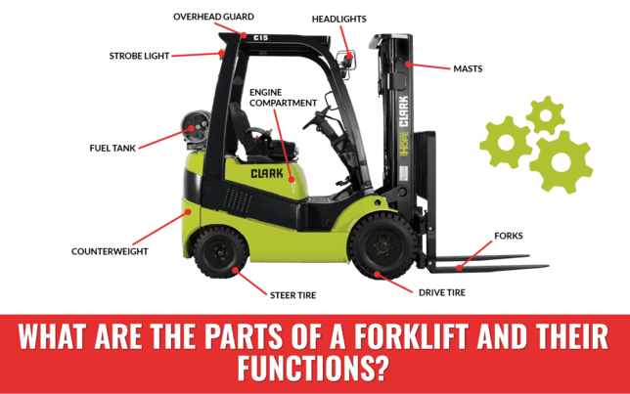Forklift |  | Designed to mechanically move brick and block materials from the ground to raised platform, reducing manual carrying activities required by workers

- Match the brick and block laying hand tool to its operational features, using an arrowed line.

Hand Tool |  | Operational Features
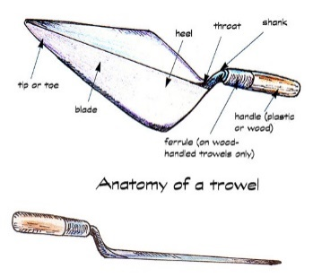Trowel |  | A bricklaying tool hit with a mash/lump hammer to break or cut masonry materials
 Ironer jointing tool |  | A bricklaying tool designed to adjust bricks, scrape off excess mortar, spread and furrow mortar, and other tasks related to laying bricks
Straight edge |  | Designed to check straightness of a brick wall or draw straight lines on materials
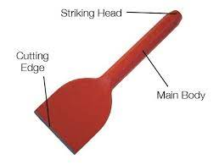Bolster chisel |  | A bricklaying tool used to shape mortar joints into round, curved or sunken

- Match the brick and block laying hand tool to its operational features, using an arrowed line.

Hand Tool |  | Operational Features
Mash/lump hammer |  | Designed to drive pegs, for demolition or for hitting a bolster to cut and break masonry materials
  Raker jointing tool |  | Used to measure, mark and transfer angles on materials
Builder square |  | A bricklaying tool used to shape mortar joints square and expose the edge of bricks
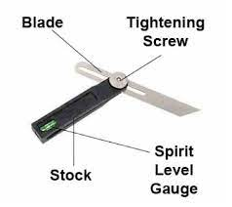Sliding bevel |  | Used to mark and check right angles in building construction

- Match the brick and block laying equipment to its operational features, using an arrowed line.

Equipment |  | Operational Features
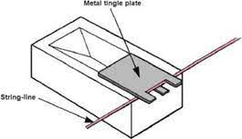Tingle plate |  | Bricklaying equipment set up in the corners of brick projects, designed efficiently set string lines to the correct course height. Features standard brick gauge measurements
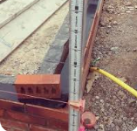Profile |  | A metal plate designed to reduce string line sag due to the excessive distance between brick corners.
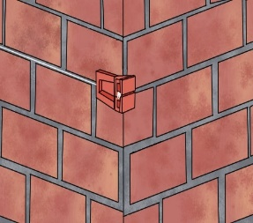  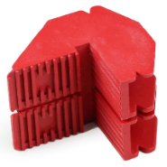  Corner block |  | Built structure that safely supports materials and workers during tasks at heights
String line |  | Used with string line to mark out the location (height and face) for a new course of bricks
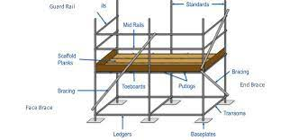Scaffold |  | Commonly used in masonry and carpentry to help the user create a straight line between two reference points.

- Match the brick and block laying levelling equipment to its operational features, using an arrowed line.

Levelling Equipment |  | Operational Features
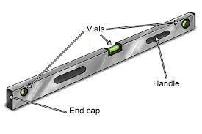  Spirit level |  | Used in conjunction with a levelling staff, it is an instrument designed to indicate level, plumb, distance and degree variance
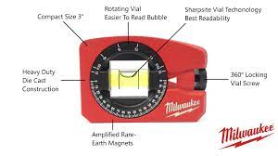  Pocket level |  | Instrument designed to indicate level and plumb on individual bricks and blocks. Magnetised and can also measure various angles.
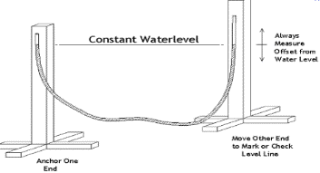  Water level |  | Instrument designed to indicate level and plumb on multiple bricks and blocks in a course. Can also be used as a straight edge.
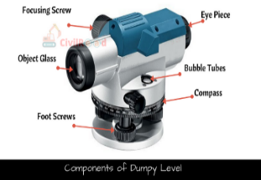  Automatic level |  | An instrument designed to produce a visual or auditory output, to illustrate levels and heights.  It emits a beam to a receiver, which allows for one person operation.
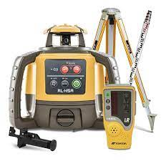Laser level |  | A transparent plastic tube filled with water, used to determine the inclination of an object or surface and for matching elevations at locations that are too far apart for a spirit level to span.

- Match the brick and block laying power tools or equipment to its operational features, using an arrowed line.

Power Tool or Equipment |  | Operational Features
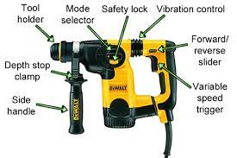Power drill |  | Used for cutting pavers, concrete blocks, and other building materials, including bricks. Usually includes a water delivered dust suppression system.
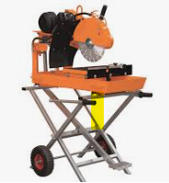  Brick cutting saw |  | A device that increases the pressure of a gas by reducing its volume, creating energy to power pneumatic tools and equipment and to provide correct air pressure to wheelbarrows
  Battery operated tools |  | Allow the operator the flexibility to use a variety of tools to carry out a variety of construction tasks away from mains power connection
 Compressor |  | Used to convert the chemical energy of petrol into mechanical energy to provide power for tools and equipment where no mains power is available
 Petrol generator |  | Used to drill and screw into various construction materials. Some have a hammer drill function for drilling into masonry.

Assessor Feedback 1 – Section 1
This Assessor Feedback form is for your Assessor to complete for each section of the assessment. Once completed your Assessor will discuss their comments with you and ask you to complete the feedback section.

Task: Written Questions
☐ Satisfactory | ☐ Not Satisfactory (additional evidence required)
Assessor feedback to student
(Include details of any gaps in performance evidence, you may wish to attach to student observation checklist. Do not provide the answers or benchmark standards)
Attempt Number (Out of 3) | 1
Assessor name | Insert assessor name here
Assessor signature | Assessor sign here
Date | Insert date here

Assessor Feedback 2 – Section 1

Task: Written Questions
☐ Satisfactory | ☐ Not Satisfactory (additional evidence required)
Assessor feedback to student
Attempt Number (Out of 3) | 2
Assessor name | Insert assessor name here
Assessor signature | Assessor sign here
Date | Insert date here

Assessor Feedback 3 – Section 1

Task: Written Questions
☐ Satisfactory | ☐ Not Satisfactory (additional evidence required)
Assessor feedback to student

Attempt Number (Out of 3) | 3
Assessor name | Insert assessor name here
Assessor signature | Assessor sign here
Date | Insert date here

Section 2: Product Based Methods

Time | Each student has 1 hour to complete this section.
Assessment Instructions | Each student must complete the assigned workplace documents.  Prior to Assessment:  - The student will be designated or approved at least 1 bricklaying project and at least 1 blocklaying project, that will allow them to complete the required assessment activities.  - The teacher can lead class discussions about the assigned workplace documents.  - Ensure all responses are a student’s own work.  After the Assessment:  - After completion, the teacher will hold a debrief (feedback) session with the student. The student will share any insights or lessons they have gained and discuss any takeaways that could be applied to real-life situations.
Students must demonstrate: | - Plan brick and block laying work  - Prepare brick and block laying work
Student to submit | Each student must submit the following evidence:  - Part A – Work Plan Bricklaying Project  - Part B – Work Plan Blocklaying Project Preparation
Resources | Each student will be provided with the following resources to complete the assessment task.  - A designated brick and block laying site  - Personal Protective Equipment (PPE) relevant to the specific brick and block laying preparation and production activities  - Plant, tools and equipment relevant to the specific brick and block laying projects and associated operator manuals, which includes:  - brick grab/carrier  - wheelbarrow  - spirit and pocket level  - automatic or laser level  - trowels and jointing tools  - cement mixer  - wet brick cut saw  - AS3700 Masonry Structures document  - Assessment Resource – New Place Construction Employee Handbook  Project related templates:  - Part A – Work Plan Bricklaying Project  - Part B – Work Plan Blocklaying Project Preparation
Reattempts | - For students deemed Not Yet Satisfactory for a task, an opportunity will be provided by the assessor to reattempt the task where possible.  - Due to the cost of material and assessment restraints, students can have a maximum of 3 attempts for this assessment.

Section 2 - PART A: Work Plan Bricklaying Project
Instructions.
The student must report on the planning and preparation of at least 1 bricklaying project and associated activities, they will undertake in Section 3 of this Task. Specifically, students must:
- Complete the Work Plan and submit to your teacher
- Discuss the completed Work Plan with your teacher
Note: Multiple students can contribute to 1 bricklaying project, providing they can achieve each of the Section 3 Direct Observation - Performance Criteria individually.

Report completed by | Student name
Work Activities and Outcomes | - Prepare the work area for the loading of bricklaying materials  - Use mechanical aids to safely and efficiently relocate and stack bricks and bricklaying materials to the worksite  - Set up a cement mixer and mix mortar to a strength of M3  - Set up a brick cutting saw and cut bricks to conform with project plans and specifications  - Lay bricks to achieve a balanced masonry finish that conforms with project plans and specifications  - Use hand tools to achieve three different joint finishes

Bricklaying Project Plan
(provided by teacher)
Insert picture

Bricklaying Procedure Sequence
Sequence Number | Work Activity | Description | Estimated Duration
1 | Prepare the work area | Find a flat area, close to the project brick wall (eg 600mm) and mortar boards. Clear any trip hazards, moveable items and debris | 30 minutes
2
3
4
5
6
7
8
9
Total estimated hours

Plant, Tools and Equipment List (include handling equipment and PPE)
(✓ or x the check box once you have confirmed it is ready for use)
Item | No. required | ☒ | Item | No. required | ☒
Safety glasses | 1 | ☐ | Cement Mixer | 1 | ☐
Earmuffs | 1 | ☐ | Wet cut brick saw | 1 | ☐
Dust mask | 1 | ☐ | Residual Current Device (RCD) | 1 | ☐
Wheelbarrow | 1 | ☐ | Brick grab/carrier | 1 | ☐
 |  | ☐ |  |  | ☐
 |  | ☐ |  |  | ☐
 |  | ☐ |  |  | ☐
 |  | ☐ |  |  | ☐
 |  | ☐ |  |  | ☐
Job Safety and Environmental Analysis (JSEA)
Activity  List hazardous tasks required to perform the activity. | Hazards  Against each task, list the physical and environmental hazards that could cause injury when the task is performed | Hazard control measures  List the control measures required to minimise the risk of injury | Who is responsible?  Name of the person to implement the control measure
Relocating bricks, blocks, materials and mortar | Trip hazards and manual handling injuries | Clear path, use correct manual handling technique and mechanical aids

Materials List
(calculate this from the teacher supplied plans and specifications)
Material | Number  Required
Brickies sand

Section 2 - PART B: Work Plan Blocklaying Project Preparation
Instructions.
The student must report on the planning and preparation of at least 1 blocklaying project and associated activities, they will undertake in Section 3 of this Task.
Note: The training package only requires the planning and preparation of a blocklaying project, therefore the blocklaying project does not have to be physically laid by students for assessment.

Specifically, students must:
- Complete the Work Plan and submit to your teacher
- Discuss the completed Work Plan with your teacher
Note: Multiple students can contribute to 1 blocklaying project preparation, providing they can achieve each of the Section 3 Direct Observation - Performance Criteria individually.

Report completed by | Student name
Work Activities and Outcomes | - Prepare the work area for the loading of blocklaying materials  - Use mechanical aids to safely and efficiently relocate and stack blocks to the worksite  - Set up a brick cutting saw and cut blocks to conform with project plans and specifications

Blocklaying Project Plan
(provided by teacher)
Insert picture

Blocklaying Preparation Procedure Sequence
Sequence Number | Work Activity | Description | Estimated Duration
1 | Prepare the work area | Find a flat area, close to the project brick wall (eg 600mm) and mortar boards. Clear any trip hazards, moveable items and debris | 30 minutes
2
3
4
Total estimated hours

Plant, Tools and Equipment List (include handling equipment and PPE)
(✓ or x the check box once you have confirmed it is ready for use)
Item | No. required | ☒ | Item | No. required | ☒
Safety glasses | 1 | ☐ | Wet cut brick saw | 1 | ☒
Earmuffs | 1 | ☐ | Residual Current Device (RCD) | 1 | ☐
Dust mask | 1 | ☐ |  |  | ☐
 |  | ☐ |  |  | ☐

Job Safety and Environmental Analysis (JSEA)
Activity  List hazardous tasks required to perform the activity. | Hazards  Against each task, list the physical and environmental hazards that could cause injury when the task is performed | Hazard control measures  List the control measures required to minimise the risk of injury | Who is responsible?  Name of the person to implement the control measure
Relocating bricks, blocks, materials and mortar | Trip hazards and manual handling injuries | Clear path, use correct manual handling technique and mechanical aids

Materials List
(calculate this from the teacher supplied plans and specifications)
Material | Number  Required

Assessor Feedback 1 – Section 2
This Assessor Feedback form is for your Assessor to complete for each section of the assessment. Once completed your Assessor will discuss their comments with you and ask you to complete the feedback section.

Task: Product Based Methods
☐ Satisfactory | ☐ Not Satisfactory (additional evidence required)
Assessor feedback to student
(Include details of any gaps in performance evidence, you may wish to attach to student observation checklist. Do not provide the answers or benchmark standards)
Attempt Number (Out of 3) | 1
Assessor name | Insert assessor name here
Assessor signature | Assessor sign here
Date | Insert date here

Assessor Feedback 2 – Section 2

Task: Product Based Methods
☐ Satisfactory | ☐ Not Satisfactory (additional evidence required)
Assessor feedback to student

Attempt Number (Out of 3) | 2
Assessor name | Insert assessor name here
Assessor signature | Assessor sign here
Date | Insert date here

Assessor Feedback 3 – Section 2

Task: Product Based Methods
☐ Satisfactory | ☐ Not Satisfactory (additional evidence required)
Assessor feedback to student

Attempt Number (Out of 3) | 3
Assessor name | Insert assessor name here
Assessor signature | Assessor sign here
Date | Insert date here

Section 3: Direct Observation

Time | Each student has 6 hours to complete this section.
Assessment Instructions | Each student must be directly observed performing the criteria on the Observation Checklist.  Prior to Assessment:  - Familiarise yourself with the observable criteria.  - Familiarise yourself with the Assessment Resource – New Place Construction Company Handbook.  - The student will be designated or approved at least 1 bricklaying project and at least 1 blocklaying project, that will allow them to complete the required assessment activities.  During Assessment:  - The teacher can lead class discussions and ask for clarification during the tasks.  After the Assessment:  - After completion, the teacher will hold a debrief (feedback) session with the student. The student will share any insights or lessons they have gained and discuss any takeaways that could be applied to real-life situations.
Students must demonstrate | - Planning brick and block laying work  - Handling, sorting and stacking materials  - Preparing brick and block laying work  - Mixing brick and block laying mortar  - Using brick and block laying plant, equipment and tools  - Cleaning up

Resources | Each student will be provided with the following resources to complete the assessment task.  - A designated brick and block laying site  - Personal Protective Equipment (PPE) relevant to the specific brick and block laying preparation and production activities  - Materials relevant to the specific brick and block laying projects, which includes:  - bricks  - blocks  - mortar (water, lime, cement, sand)  - corner blocks  - string lines  - profiles  - mortar boards  - Plant, tools and equipment relevant to the specific brick and block laying projects and associated operator manuals, which includes:  - brick grab/carrier  - wheelbarrow  - spirit and pocket level  - automatic or laser level  - trowels and jointing tools  - cement mixer  - wet brick cut saw  - Relevant material delivery docket  - AS3700 Masonry Structures document  - Assessment Resource – New Place Construction Employee Handbook  - Section 2 Part A – Work Plan Bricklaying Project  - Section 2 Part B – Work Plan Blocklaying Project Preparation  - Instructions on the Performance Criteria that need to be achieved and observed by the assessor.
Reattempts | - For students deemed Not Yet Satisfactory for a task, an opportunity will be provided by the assessor to reattempt the task where possible.  - Due to the cost of material and assessment restraints, students can have a maximum of 3 attempts for this assessment.

Section 3 – Student Instructions
Observation Checklist – Part A – Scenario Simulation
Scenario 1 – You are working as an apprentice bricklayer on a residential construction site. You have been asked to cut bricks, but you notice the brick cutting saw guard is broken and therefore ineffective.

Following New Place Construction workplace procedures (Employee Expectations - Equipment Maintenance and Breakdowns):
- demonstrate how you would respond
- demonstrate the reporting process

PC # | Performance Criteria | In Observation Checklist – Part A, you must demonstrate:
1 | Respond to identified equipment damage | Following workplace procedures when responding to equipment damage
Scenario 2 – A delivery of bricks and bricklaying materials have just been delivered, and your boss has asked you to check these before signing the delivery docket. You notice some of the bricks have been broken and some cement bags have been wet and hardened.

Following New Place Construction workplace procedures (Employee Expectations – Material Deliveries):
- demonstrate how you would respond
- demonstrate the reporting process

PC # | Performance Criteria | In Observation Checklist – Part A, you must demonstrate:
2 | Report material damage and inconsistencies | Following workplace procedures when reporting material damage and/or inconsistencies

Observation Checklist – Part B – Planning
Prior to undertaking the brick and block preparation and production activities, you must demonstrate safely following WHS and workplace procedures to plan for them.
PC # | Performance Criteria | In Observation Checklist – Part B, you must demonstrate:
3 | Read and interpret the project work plan, specifications and masonry code | - Reading and interpreting project planning documents, including:  - Work plans  - Bricklaying plans, pictures or drawings  - AS3700 Masonry Structures  - Verbally repeating to the teacher important information within these documents
4 | Read and interpret plant, tool and equipment operator manuals | - Reading and interpreting information within the operator manuals for the plant, tools and equipment identified for use, including:  - Pre-operational checks  - Safe operating procedures  - Limitations  - Verbally repeating to the teacher important information these documents
5 | Conduct pre-operational checks on bricklaying plant, tools and equipment | - Conducting pre-operational checks on bricklaying plant, tools and equipment, which must include a cement mixer  - ✓ or x the check box in the Plant, Tools and Equipment List once it is confirmed ready for use  - Verbally reporting identified faults to the supervisor (only if required)
6 | Set up, level and stabilise a cement mixer | Setting up, levelling and stabilising a cement mixer, which must include connection to a Residual Current Device (RCD)
7 | Set up, level and stabilise a raised mortar board | Setting up, levelling and stabilising a raised mortar board
8 | Prepare work area for loading of materials | Preparing the work area for the loading of materials
9 | Check materials against the delivery docket | Checking material quantity and quality against a material delivery docket (supplied by the teacher)

Observation Checklist – Part C – Project Preparation
While undertaking brick and block preparation activities, you must demonstrate safely following WHS and workplace procedures.
PC # | Performance Criteria | In Observation Checklist – Part C, you must demonstrate:
10 | Follow WHS hazards controls, including PPE use | Following Work Health and Safety (WHS) hazards controls, including PPE use
11 | Safely prepare, sort, handle, relocate and stack bricks and blocks using a mechanical aid | Safely preparing, sorting, handling, relocating and stacking bricks and blocks using a mechanical aid, including at least:  - 1 pallet of bricks  - Enough blocks to conform with plans and specifications
12 | Safely cut bricks and blocks with a wet cut brick saw, to conform with plans and specifications | Safely cutting bricks and blocks with a wet cut brick saw, to conform with plans and specifications, including:  - Setting up, levelling and stabilising the wet cut brick saw, which must include connection to a Residual Current Device (RCD)  - Conducting pre-operational checks  - Cutting at least 1 brick and at least 1 block

Observation Checklist – Part D – Bricklaying
While undertaking the designated bricklaying project, you must demonstrate safely following WHS and workplace procedures.
PC # | Performance Criteria | In Observation Checklist – Part D, you must demonstrate:
13 | Mix and produce consistent mortar to a strength factor of M3 | - Using the bucket gauging technique to mix and produce consistent mortar to a strength factor of M3  - Confirming the quality and consistency of the mortar with the teacher
14 | Safely handle, relocate and load mortar onto raised mortar boards using a mechanical aid | Safely handling, relocating and loading mortar onto raised mortar boards using a mechanical aid
15 | Blend and lay bricks to achieve a balanced masonry finish that conforms with project plans and specifications | Using bricklaying hand tools to blend and lay bricks to achieve a balanced masonry finish that conforms with project plans and specifications
16 | Use hand tools to achieve three different joint finishes | Using hand tools to achieve three different joint finishes

Observation Checklist – Part E – Cleanup
After completing the designated bricklaying project activities, you must demonstrate safely following workplace and manufacturer procedures to cleanup.
PC # | Performance Criteria | In Observation Checklist – Part E, you must demonstrate:
17 | Clear work area and dispose of materials | Following workplace procedures to clear the work area and dispose of materials, including reusing and recycling materials where possible
18 | Disconnect, clean and store portable electrical equipment | Following workplace and manufacturer procedures to disconnect, clean and store the cement mixer and wet cut brick saw
19 | Clean, check and maintain tools and equipment | - Following operator manual instructions to clean, check and maintain bricklaying tools and equipment  - Verbally reporting identified faults to the supervisor (only if required)
20 | Store tools and equipment | Following workplace procedures to store bricklaying tools and equipment

Assessor Feedback 1 – Section 3
This Assessor Feedback form is for your Assessor to complete for each section of the assessment. Once completed your Assessor will discuss their comments with you and ask you to complete the feedback section.

Task: Direct Observation
☐ Satisfactory | ☐ Not Satisfactory (additional evidence required)
Assessor feedback to student
Some aspects of the observation checklist have not been demonstrated and or some observations did not meet the required benchmark standards.
(Include details of any gaps in performance evidence, you may wish to attach to student observation checklist. Do not provide the answers or benchmark standards)
Attempt Number (Out of 3) | 1
Assessor name | Insert assessor name here
Assessor signature | Assessor sign here
Date | Insert date here

Assessor Feedback 2 – Section 3

Task: Direct Observation
☐ Satisfactory | ☐ Not Satisfactory (additional evidence required)
Assessor feedback to student

Attempt Number (Out of 3) | 2
Assessor name | Insert assessor name here
Assessor signature | Assessor sign here
Date | Insert date here

Assessor Feedback 3 – Section 3

Task: Direct Observation
☐ Satisfactory | ☐ Not Satisfactory (additional evidence required)
Assessor feedback to student
Attempt Number (Out of 3) | 3
Assessor name | Insert assessor name here
Assessor signature | Assessor sign here
Date | Insert date here
Final Assessment Outcome
This form will be completed by your assessor at the completion of the task
Student name | Insert student name
Assessor name | Insert Assessor name
Task | Task 5.1 – Brick and Block Laying
Units of competency | CPCCBL2002 – Use bricklaying and blocklaying tools and equipment  CPCCBL2001 – Handle and prepare bricklaying and blocklaying materials
The following reasonable adjustments have been implemented:  - in accordance with industry standards  - are fair and equitable and do not compromise the integrity of the task  - assess all aspects of the unit of competency | Further reasonable adjustments  Some examples of reasonable adjustment may include:  - Altering/simplifying the language used  - Providing support staff  - Providing tutorial sessions – this is part of delivery before assessment  - Providing additional time to complete the task within industry standard  - Altering the collection of knowledge evidence, using verbal questioning instead of written. The student’s response be recorded by the assessor/scribe and annotated with a “V” next to a written response.

Unit of Competency | Final Assessment Outcome  Competent / Not Yet Competent (NYC)
CPCCBL2002 – Use bricklaying and blocklaying tools and equipment | Competent | Not Yet Competent
CPCCBL2001 – Handle and prepare bricklaying and blocklaying materials | Competent | Not Yet Competent

Overall Feedback
Student name | Insert student name here
Course Feedback:

I declare that I have conducted a fair, valid, reliable and flexible assessment with this student, and I have provided appropriate feedback
Assessor name | Insert assessor name here
Assessor signature | Assessor to sign here
Date | Insert date here

Student feedback
Please provide feedback to your assessor regarding this assessment task |  | Yes | No | Unsure
Did the class work before assessment help you to complete this Student Assessment Package?
Were the student instructions in the Student Assessment Package clear?
Do you feel you were provided enough opportunity for you to demonstrate your industry knowledge and skill for the unit of competency being assessed?
Were you given enough feedback about your performance at the end of every task and assessment?
Could this assessment or tasks within this assessment be improved? If yes, how? (record your response in the space below)
Will you be continuing your VET studies in this industry when you leave school?
Student self-evaluation comment (optional) e.g., areas I would like to improve on, new skills learnt, or general comments.
Student to write comment here

Student name | Insert student name here
Student signature | Student to sign here
Date | Insert date here

